Paper Walker

### Readers: Anna & Jonathan, DOLE: 23-4-2021

Uncertainty: limited knowledge on past, present, future events, systems, parameters, variables, external factors, etc.

Risk is a low-level uncertainty (probability * loss) <-> Deep uncertainty is a high-level uncertainty (lack of consensus on knowledge or values)

Deep uncertainty/severe uncertainty: uncertainties about the state of the world and human factors for which we know absolutely nothing about probability distributions and little about the possible outcomes (Quade 1989). Or: The condition in which analysts do not know or the parties to a decision cannot agree upon (1) the appropriate models to describe interactions among a system’s variables, (2) the probability distributions to represent uncertainty about key parameters in the models, and/or (3) how to value the desirability of alternative outcomes (Lempert 2003).

Example of uncertainty in policy making: PKB Schiphol Airport (1990s): Need to make policies for planning and growth. They hired some modelers who failed Kwakkels class; These guys said hey! Our machine learning model automatically correlates xyz, this means the GNP is correlated to passenger throughput. Cool. Let's tell little Willem (minster at the time controlled by the monarchy) to make a policy based on our projections. RESULTS: Passenger throughput skyrocketed & max. capacity was reached in 8 years instead of 25. (woopies). Now Passenger throughput was related to GNP but had sensitivity to other external factors… a.k.a. airport become a hub to get to other places via KLM & Co. (alliances), which the modelers had no clue of. So, the modelers had modeled using the (empirical/rational) past to predict the future (problem of induction) instead of thinking of new creative ways that the airport might grow. So, the black swan event happened in their lifetime and …. (ahh fuck. kwakkels told you so. )

Scenario: A description of the conditions under which the system or policy to be designed, tested, or evaluated is assumed to perform (Quade, 1989).

Epistemic uncertainty: can be reduced by collecting more information or waiting <-> aleatoric uncertainty: some uncertainty will always remain (gamble). Statistics can be used for aleatoric, this chapter focusses on epistemic.

4 types of parameters: exact parameters (constants such as pi), fixed parameters, determined by previous investigations that can be considered exact (g), chosen parameters, calibrated parameters (minimising difference between model outcomes and measured data).

**Two important classifications of uncertainties:**

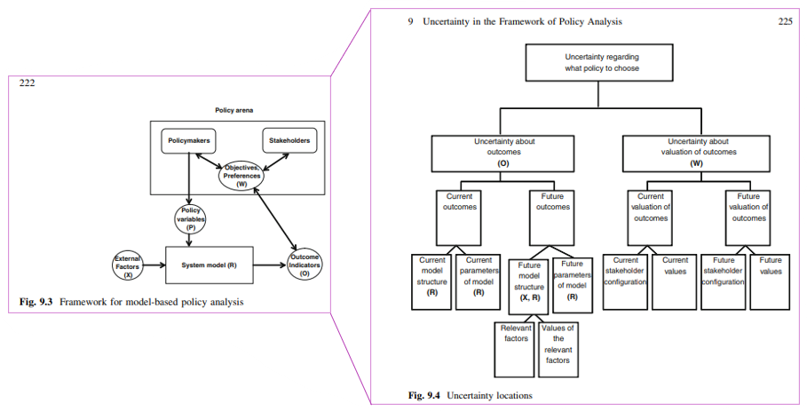

* **[1]Location** in the policy analysis framework   
  X = Context: external factors  
  R = System model: response to factor/policy changes  
  O = System outcomes (prediction error)  
  W = Weight on outcome: relative importance of the outcomes according to participants.

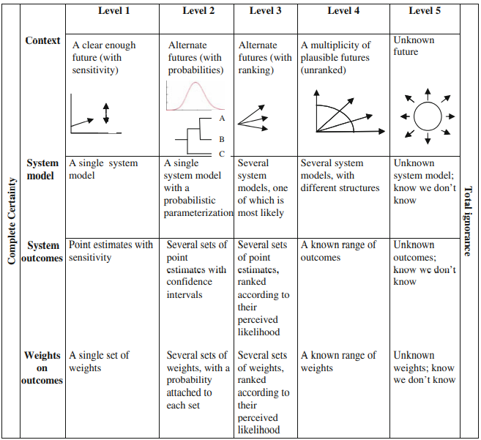

* **[2] Level:** Uncertainty Magnitude? (see figure Right)

Level 1: Situation is not absolutely certain, but unwilling/able to measure the degree of uncertainty 🡪 sensitivity analysis of model parameters.

Level 2: Describable in statistical terms 🡪 make forecasts/scenario’s with probabilities

Level 3: Alternatives are rankable in perceived likelihood 🡪 trend-based scenarios.

Level 4: Alternatives are defined without relative likelihoods. (Deep uncertainty)

Level 5: We only know what we don’t know. (Deep uncertainty)

*Note** Level 1 and 2 uncertainties are fit for quantitative analytical approaches.*

**Ways to deal with uncertainty while conducting policy analysis:**

* Level 1: **Predict-and-act approac**h: Use a single model and perform a sensitivity analysis on the parameters. Then use a cost-benefit analysis, multi-criteria analysis, or other optimisation technique to find the best policy. It is dangerous to base your policy on only 1 model most likely scenario because it is very likely it will not be this specific one. Plus, the past is a bad predictor for the future.
* Level 2: **Expected outcomes approach**: make a model for each future and estimate the outcomes of policies in these scenarios. (this is what ASD and ABM are often focussed on). Evaluation methods / tools: Cost-benefit-Analysis; Decision An analysis; Real Options Analysis (ROA) (basically what our ethics course is focusing on).
* Level 3: Typically treated by reducing to level 2 by assigning probabilities to the ranking or treat them as equal. Find a policy that performs well on the likely ones and not too bad on the less likely ones. Sometimes treated with Level 4 methods (scenario planning).
* Level 4: 2 ways:
  + **Static robustness/scenario planning**: Find a robust policy across a range of plausible futures (Heijden, 1996). 4 criteria for defining scenarios:
    - Consistency (assumptions don’t self-contradict)
    - Plausibility: posited chain of events can happen
    - Credibility: change in the chain can be explained
    - Relevance: Changes of values in variables is likely to have a large effect on at least one outcome of interest.

Steps to follow:

* + - Specify the system, its outcomes of interest, and the relevant time horizon.
    - Identify relevant external factors and driving changes in the system (X and R leading to O).
    - Categorize factor and resulting system changes in uncertainty (y/not really).
    - Assess the relevance of the uncertain factors/system changes: which ones have the largest impact on the interesting outcomes.
    - Design several scenarios by combining different developments in the external factors.

Three benefits of scenario analysis: helps to deal with situation with many sources of uncertainty, it allows what-if examination, and is a way to explore level 4 uncertainty.  
Problems: dividing which factors to include, values of external factors are often uncertain, and the large range in the performance estimates. Often that still leads to just using the most likely scenario or doing nothing because there is not enough info to make an informed decision.

* + **Exploratory modeling and analysis approach**: closely related to Robust Decision making. Tries to analyse and reason about the system’s behaviour showing possible behaviour of the system. Research a broad range of assumptions and circumstances using experiments. Can also be used for scenario discovery.
* Level 5: 3 ways:
  + Resistance: plan for the worst-case scenario (costly and often does not work well due to black swans)
  + Resilience: make sure your system can recover quickly
  + Adaptive robustness: prepare to change the policy in case conditions change. (most robust and efficacious (Kwakkel, 2012).

**Dynamic Adaptive Policymaking**: Use a monitoring system and respond when specific trigger values are reached. The policy has to combine time urgent actions with actions that shape the future, preserve needed flexibility and protects the policy from failure.   
The goal is known and does not change but the path adjusts along to way to deal with changes. The process consists iteratively of the Policy Design phase (5 steps) and the Implementation phase (2 steps) (also see figure next page).

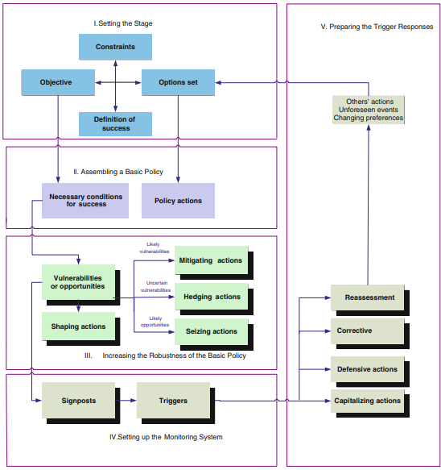**Policy design phase:**

1. Stage setting: specifications of system boundary, objectives, constraints, and policy options. 🡪 definition of success/desirable outcomes.
2. Assembling a basic policy: specification of a promising policy and identification of conditions for it to succeed.
3. Increasing the robustness of the basic policy: specify actions to be taken immediately. Identify vulnerabilities and opportunities (external developments, use scenarios/EMA for this) in the basic policies and think of actions in anticipation or response.
   * *4 types of actions*: Mitigating, Hedging (reduce risk of uncertain adverse effects of the basic policy), Seizing, Shaping (reduce the chance that the external condition makes the policy fail).
4. Setting up the monitoring System
5. Design the portions of the adaptive policy that may be implemented in the future. Can be Defensive, corrective, or capitalizing action, or Reassessment (critical analysis and assumptions failed, go back to 1).

Implementation phase:

1. Implementing pdp steps 1-4
2. Adapting the initial policies (doing the pdp step 5)